BAHRIA UNIVERSITY KARACHI CAMPUS
Department of Computer Science

DIGITAL LOGIC DESIGN

LAB EXPERIMENT # 13

Decade and Binary Counter

TASKS

- By using the IC DM7490 make the circuit for BCD 4-bit counter by using the function table.
- Then connect the BCD to seven segment decoder to display the count from 0 - 9.

CIRCUIT:
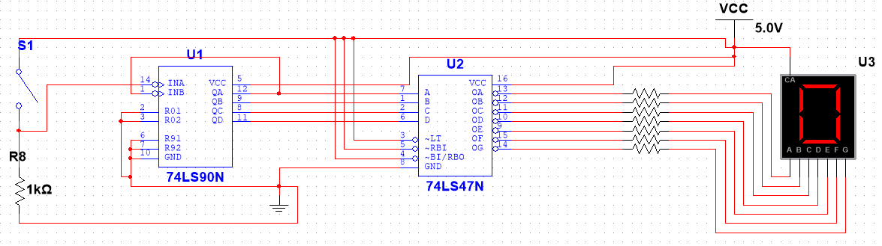

DISPLAY FROM 0 TO 9:

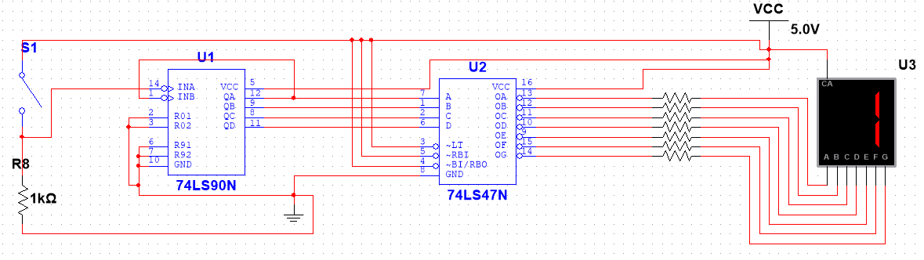
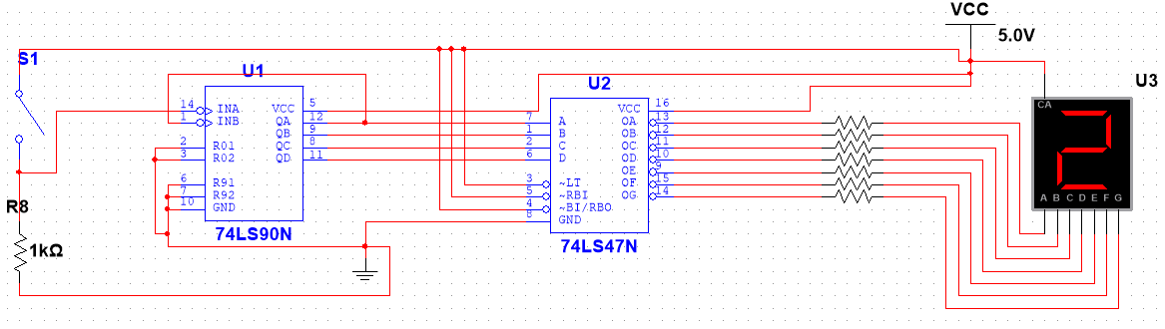
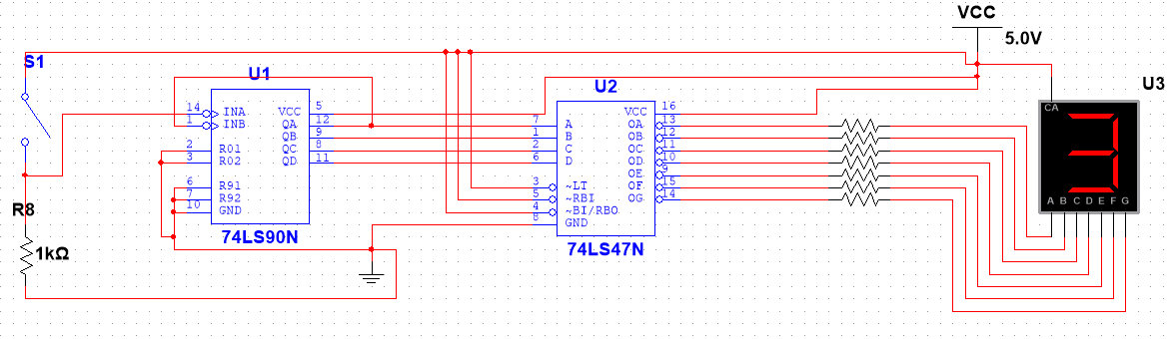
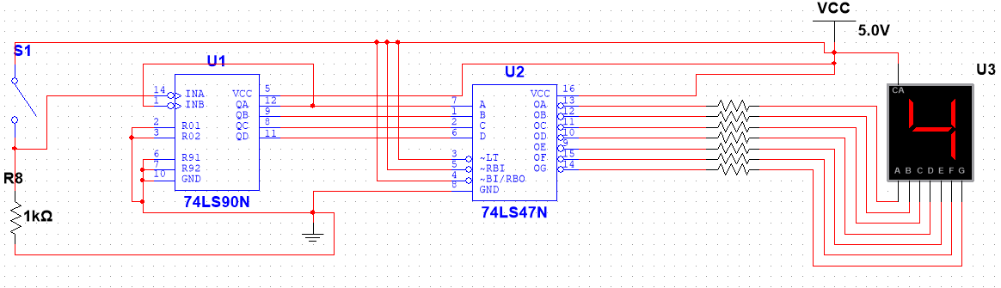
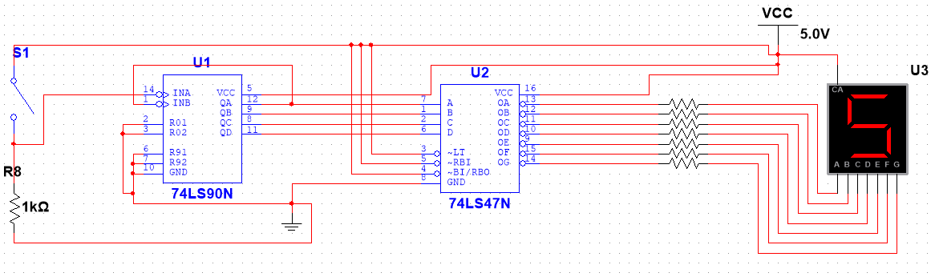
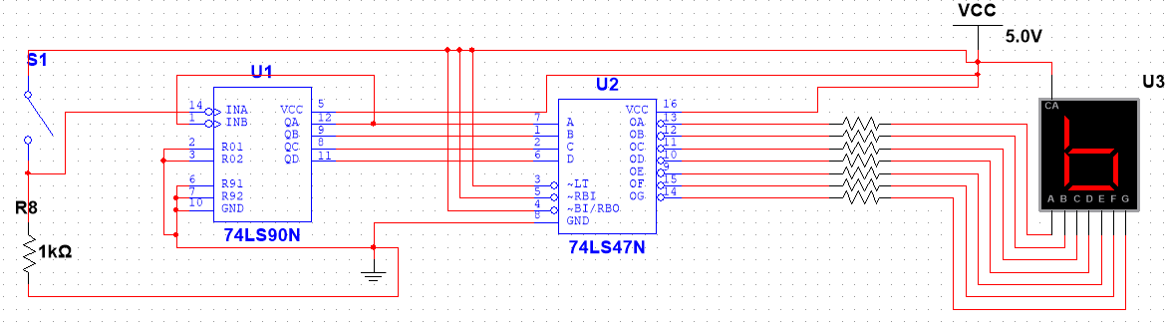
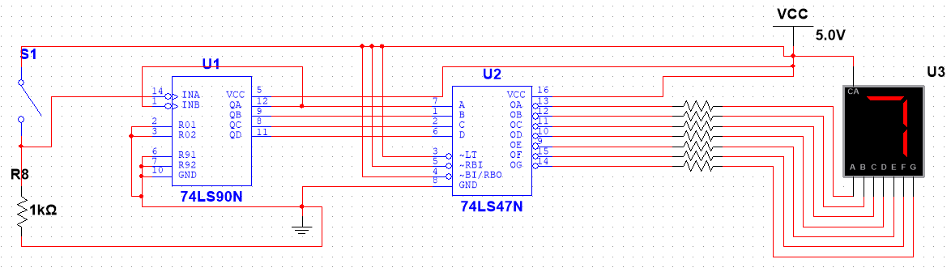
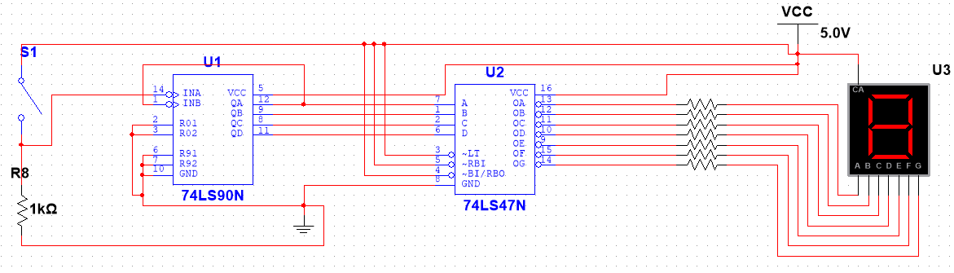
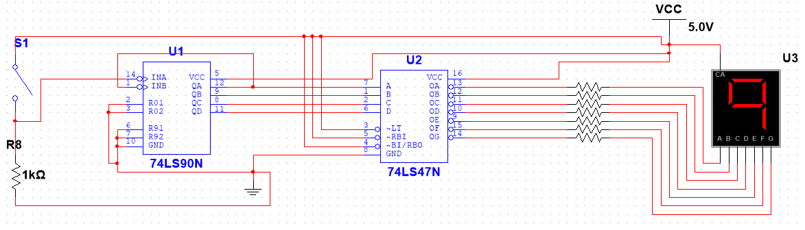

Teacher Signature: ________________________

Student Registration No.:02-134241-048

